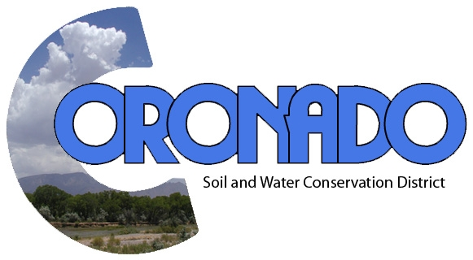
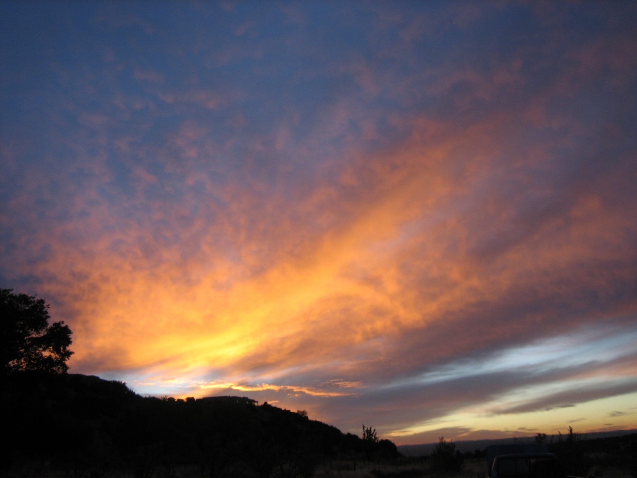

ANNUAL REPORT FY18
(July 1, 2017 – June 30, 2018)

MISSION STATEMENT
To conserve, protect and enhance our soil, water and agriculture and to prevent floodwater and sediment damage

VISION STATEMENT
To be the “eyes on the ground” to protect our natural resources

BOARD of SUPERVISORS
Lynn Montgomery, Chair
Alfred Baca, Vice-Chair
Orlando Lucero, Secretary-Treasurer
Marvin Mendelow, Supervisor
Kathleen Groody, Supervisor
Patricia Bolton, Associate Supervisor
Mary Catherine Baca, Associate Supervisor

STAFF
Carolyn Kennedy, District Manager

Email: info@coronadoswcd.org
Website: www.coronadoswcd.org

CORONADO SOIL AND WATER
CONSERVATION DISTRICT
ANNUAL REPORT-FY18
Coronado had good year. The Board became a more cohesive group, with supervisors becoming more active and expanding their roles. More events and workshops were attended. Supervisors brought back a lot of valuable information. Soil and water issues became more known within local government and the public, as drought and accompanying floods heightened awareness of them. Coronado is taking advantage of this.

DISTRICT FINANCIALS
Coronado SWCD met all its financial obligations, requirements, and deadlines. District Manager Kennedy and Secretary-Treasurer Bolton continued to keep the books together. Orlando Lucero became Secretary-Treasurer after Patricia Bolton resigned in April 2018. Carolyn Kennedy completed a course on the new LGBMS online budget submittal template and policy and received a certificate. At the beginning of FY18 the District had a cash balance of $19,870; during the year it received $14,057 and spent $16,330.
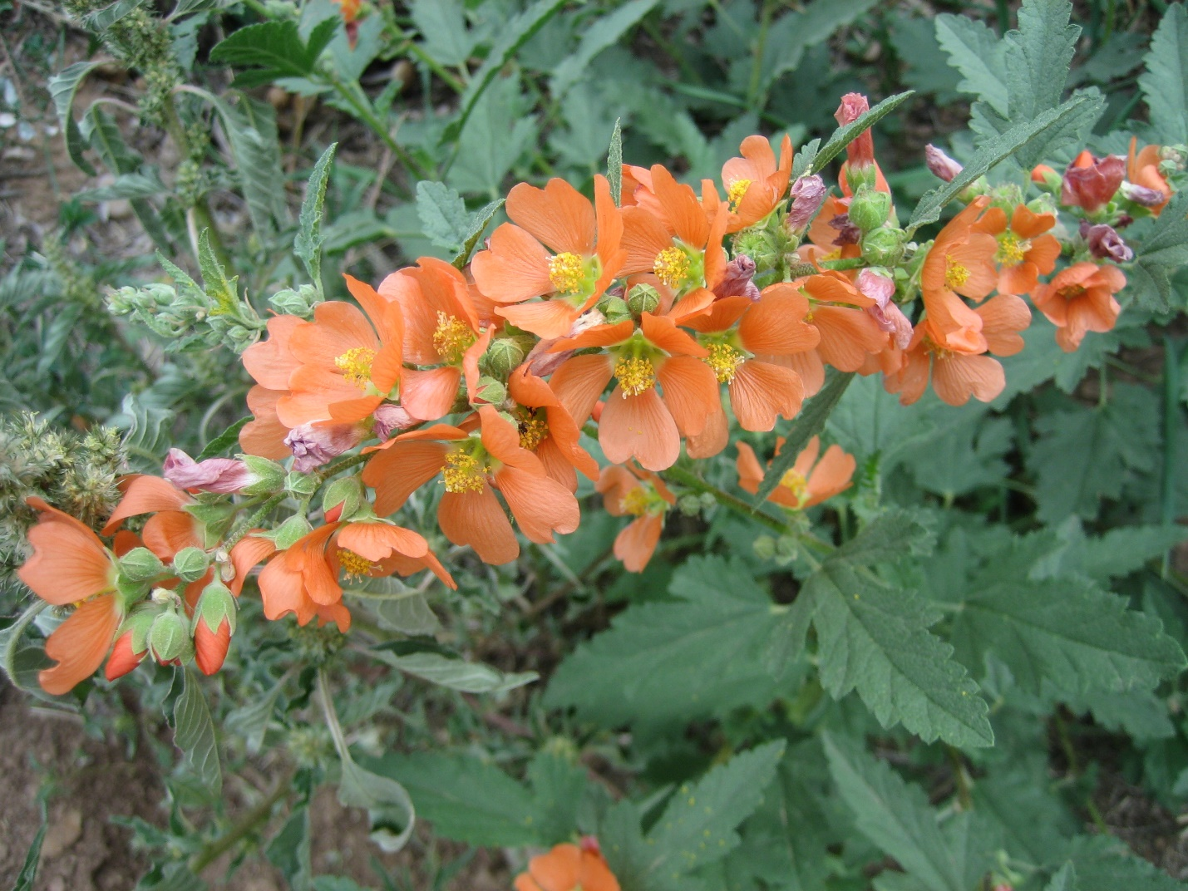
Desert Globemallow

BOARD OF SUPERVISORS
The Board had some significant changes. Orlando Lucero was elected to Position 4 in May 2017 and took office in July 2017. Patricia Bolton resigned from Position 1 in August 2017, and Jon Couch was appointed to that position in September. At that time, he was also elected Secretary-Treasurer and Ms. Bolton was appointed Associate Supervisor. Because of the demands of his business, Mr. Couch resigned in March 2018. Kathleen Groody, an agricultural producer from Sile, NM, was appointed to replace him in Position 1 in April 2018. Within a very short time, she became an integral part of the board. Also in April, Orlando Lucero was elected Secretary-Treasurer. Judith Hurley resigned as Associate Supervisor in May 2018 because of retirement. She had created and managed Coronado’s website for many years. Coronado is grateful for her service. Mary Catherine Baca was appointed in her stead and has done a great job of taking over as webmaster. We have an excellent website: www.coronadoswcd.org. The Board consisted, at the end of FY18, of the following:
Lynn Montgomery, Chair
Alfred Baca, Vice-Chair
Orlando Lucero, Secretary-Treasurer
Marvin Mendelow, Supervisor
Kathleen Groody, Supervisor
Patricia Bolton, Associate Supervisor
Mary Catherine Baca, Associate Supervisor and Webmaster

MEETINGS
The District held twelve regular monthly meetings with a quorum present, as well as two special meetings, to approve a letter of support for the Greater Rio Grande Watershed Alliance grant proposal and to update its FY18 Action Plan.

PIEDRA LISA DAM
The Piedra Lisa Flood Control Dam is co-sponsored by the District (which owns the easement to the Dam property), the Town of Bernalillo and Sandoval County, which share maintenance and emergency response responsibilities. Coronado operates the dam. NRCS provides engineers and other assistance and the Office of the State Engineer Dam Safety Bureau conducts inspections and provides advice.
There were no significant events during FY18. Sandoval County continued maintenance on the dam.
A camera inspection of the outlet conduit was completed by Southwestern Sewer Systems in August 2017, and the annual joint NRCS-Coronado informal inspection took place in November 2017.
Orlando Lucero attended the annual Watershed and Dam Owners Coalition Spring Workshop in Las Cruces on behalf of Coronado.

WATER
When it comes down to it, water is part of everything Coronado does. How we take care of the water determines our future. Coronado takes water issues seriously and its supervisors and staff are members of public and private water organizations. This year, as intense drought and heat descended on the District, water again became a pressing issue.
Mr. Mendelow is on the Board of the Algodones Community Water System and is Coronado’s alternate delegate to the Water Resources Board of the Mid-Region Council of Governments. Mr. Baca assists the MRG Conservancy District in maintaining its ditches and is active in flood control issues impacting Algodones. Ms. Kennedy is the Secretary-Treasurer of the Board of the Middle Rio Grande Water Assembly, now the MRG Water Advocates, and a parciante of Las Acequias de Placitas. Mr. Montgomery is Coronado’s delegate to the Water Resources Board, represents Coronado on the board of the MRG Water Advocates, is Coronado’s delegate to the Rio Grande Fund, is the alternate delegate to the Congreso de las Acequias of the NM Acequia Association for the Placitas Acequia Region, and is the Mayordomo of Acequia la Rosa de Castilla. Kathleen Groody is involved in the community water system in Sile. She has a 25-acre alfalfa farm there. Mr. Lucero is involved in local aquifer protection and still farms and maintains an orchard.
Because of the overriding need for strategic planning for the future in the face of this dwindling resource, Coronado Supervisors and the District Manager attended numerous meetings and conferences concerning water. Coronado is a partner in the Middle Rio Grande Conservancy District’s Drought Contingency Plan update and is taking part in the Bureau of Reclamation’s Middle Rio Grande Basin Study.

SOILS AND WATERSHED
The watershed restoration project on the Placitas Open Space was on hiatus this year. Another grant to continue the project was applied for and received from the NM Soil and Water Conservation Commission for FY19.

FORESTS
Coronado is exploring treating the Sandia Wilderness Area to prevent a catastrophic fire that would impair the water resource of Placitas.

FIRE
Fortunately, there were no significant fire events in the District during the past fiscal year. The District sponsored two chipper days in Placitas to assist residents in removing brush, which is an ongoing fire hazard.

ACEQUIAS
Acequias, even though they are few and small, are an important element for Coronado SWCD. They keep small upland agriculture alive and preserve an ancient culture still alive in Northern NM. Coronado was awarded Capital Outlay grants to restore all the reservoirs of the Placitas Acequias in FY14. The funds were spent on engineering and design. Capital Outlay was again applied for in FY16 through Sen. Sapien’s office and the project gained $50,000 to complete the engineering plans.
The three Placitas Acequias now have complete plans, which makes four of the reservoirs “shovel ready”. This turned out to be important since there was no Capital Outlay distributed in the 2017 legislative session. Alternate funding was sought through the new NRCS acequia RCPP grants, which deal directly with acequia associations. One acequia, la Rosa de Castilla, has applied for one of these. The Acequias have met with the design engineers to discuss how to best expend the remaining capital outlay funds.

PUBLICITY
July 2017, Sandoval Signpost article, “Coronado District Residents Chip in for Fire Reduction”
August 2017, Sandoval Signpost article, “Deal to Build Algodones Flood Dam Down to Details”.
September 2017, Sandoval Signpost article, “Wood Chipper Day Returns”
September 2017, Sandoval Signpost article, “Soil District Honors Supporters, Aids Reservoir Improvements”
February 2018, Sandoval Signpost article, “Flood protection Coming for Part of Algodones”
April 2018, Sandoval Signpost article, “We Treat Our Soil Like Dirt”
June 2018, Sandoval Signpost article, “Coronado Soil and Water Conservation District Sponsors Chipper Day”

PARTNERS
Cibola National Forest
Coronado has a memorandum of understanding with Cibola to assist in the drafting and implementation of the update to the 2003 Plan. This effort has been slowed down to adjust to the new administration.
Rio Puerco Management Team
This is a stakeholder and partners advisory group to the BLM. The BLM Rio Puerco Region is large with a diverse population. Coronado is within this Region. Coronado has also joined the planning committee to map out the future restoration of the Region’s watersheds. There is a new watershed-based plan for the Upper Rio Puerco/Rio San Jose Basins so that funds could be sought to carry out projects. Carolyn Kennedy edited the final version. The Watershed-Based Plan was approved in January 2018. A proposal for EPA 319 funds was applied for in June 2018. Funding matches are required for these grants and Coronado provides in-kind activities to help with this.
Greater Rio Grande Watershed Alliance
This is a group of contiguous SWCDs for conceiving, building, and realizing watershed projects through state and federal funds.
NM Association of Consevation Districts
Mr. Montgomery continued as Chairman of Region I. He attended all the Board meetings and monthly phone conferences during the year. He, Ms. Bolton and Ms. Kennedy attend the NMACD Annual Meeting in Taos October 25-26, 2017, and they, along with Mr. Lucero, attended the Mid-Year meeting in Ruidoso June 11-12, 2018.

NM Coalition of Conservation Districts
Coronado attended the NMCCD Annual Meeting in October 2017, as well as a breakfast meeting in Santa Fe during the 2018 legislative session.
Rio Grande Fund
Coronado is a signatory of this grand effort to treat the watersheds of the Rio Grande Basin and beyond.
NM Watershed and Dam Owners’ Association
Coronado is a member because of its sponsorship of the Piedra Lisa Dam. Orlando Lucero attended this year’s conference in Las Cruces in May.
Sandoval County Biomass Working Group
This exciting initiative to explore founding a biomass processing plant in the County has great potential to solve the excess carbon material left in the forest after thinning projects. Coronado provides in-kind activities to help with matches.

CONCLUSION
Coronado had a busy and successful year. Outreach to the Rio Puerco and its overwhelming watershed problems has been influential. In the future, it is hoped to tackle issues from a regeneration and resilience platform, meeting the demands of future climate challenges. Our natural resources have been sorely neglected. Coronado will help local, state, and federal agencies to better recognize the important issues concerning our natural resources and strive to bring them into better focus among government agencies and the public.

